HOW TO DOWNLOAD & CROP A PHOTO

Step 1: Navigate to the desired image asset in PhotoShelter.
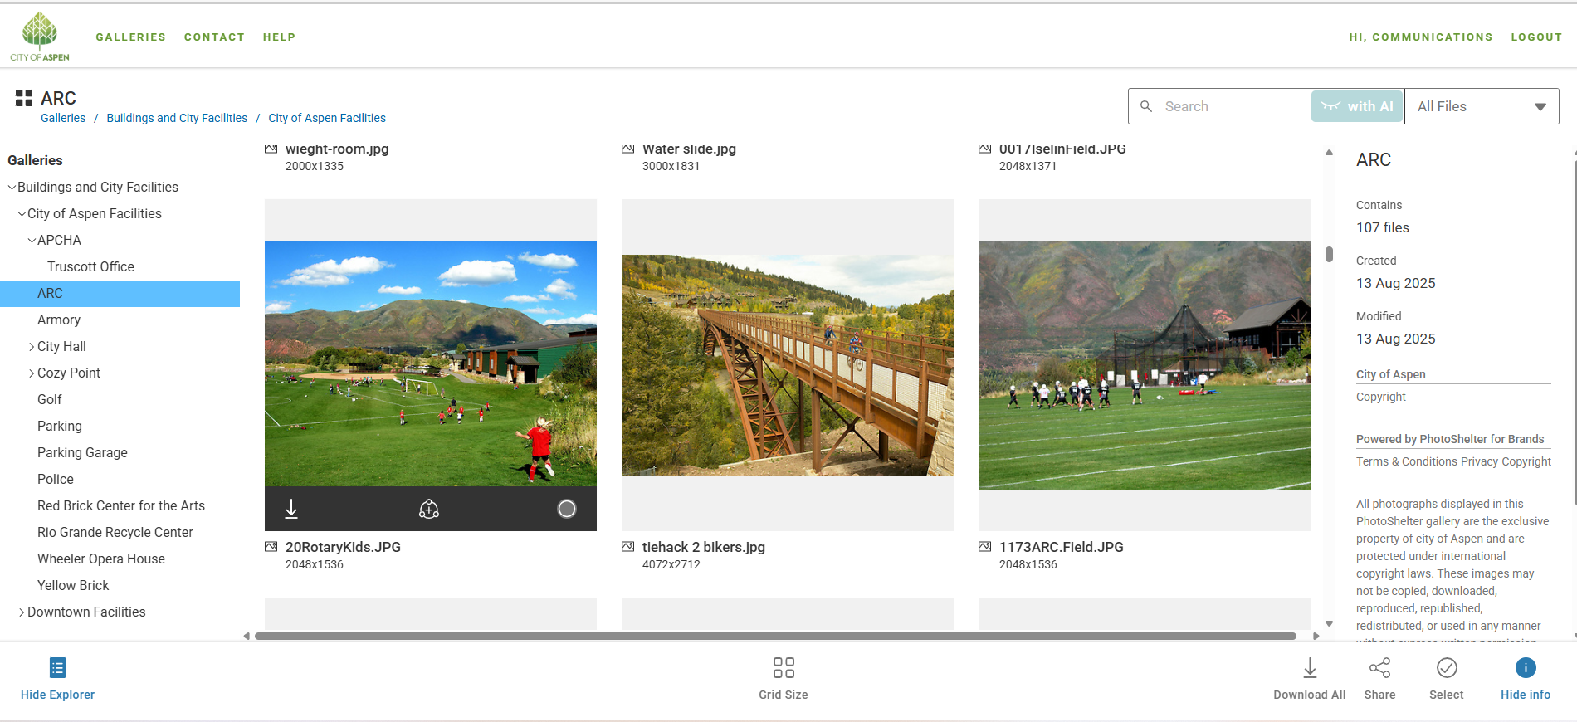
Step 2: Click the Download button.
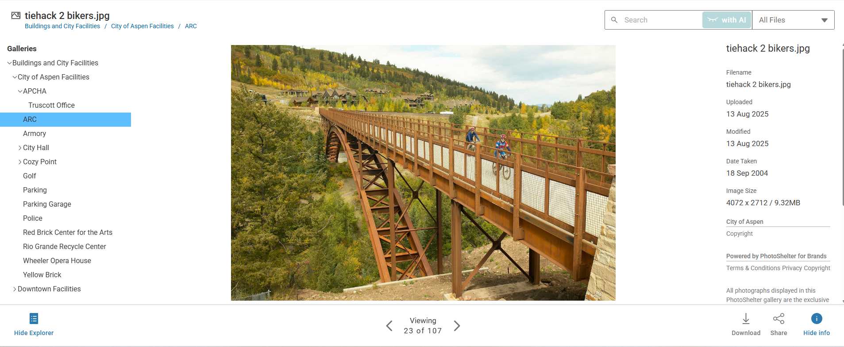

Step 3: Choose Image Format and Size
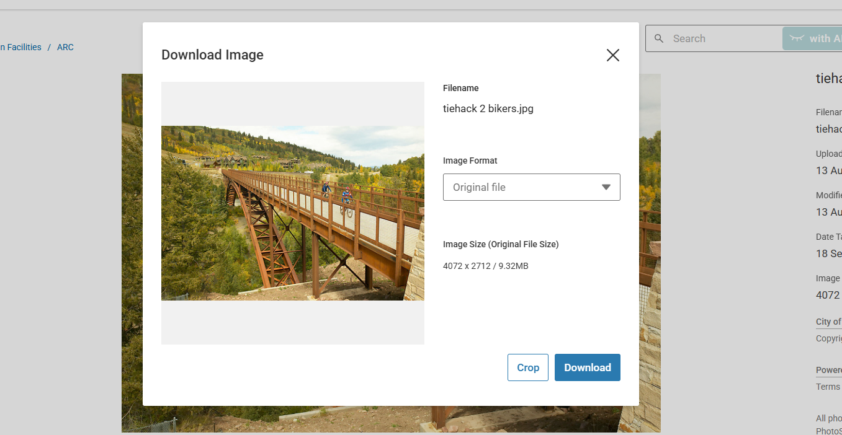
- When prompted, select the preferred image format, Choose a format related to the project you are working on.
  - Original File
  - JPEG M 1200 px
  - JPEG S 600 px
- Example: for social media use, choose a smaller file size to optimize loading and display.
  - Example: Select Small JPEG.

Step 4: Adjust Image Aspect Ratio
- Choose from the available cropping options:
  - Original
  - Custom
  - Square
- Alternatively, select from the list of preset social media aspect ratios (e.g., Facebook Cover, Instagram Post, Twitter Header, etc.).
  - Example: Select Facebook Cover.
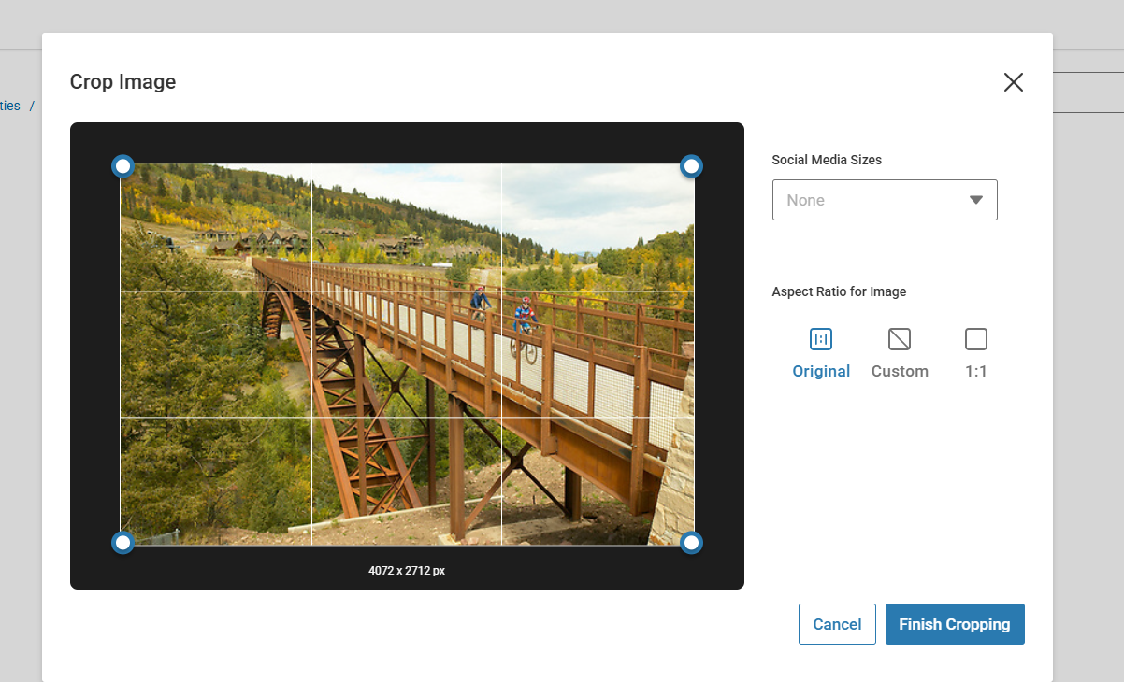
Step 5. Once satisfied, click Finish Cropping.

Step 6: Download Cropped Image
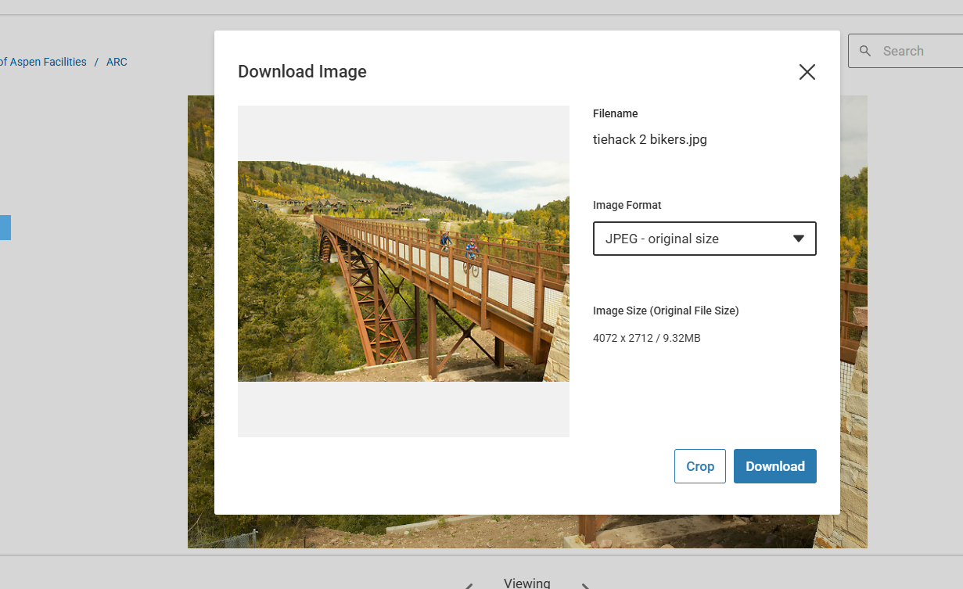
- Click Download to save the cropped image to your local device.
- The downloaded image will reflect your chosen format and aspect ratio, while the original file remains unaltered.
- Find the download photo on your download files.

